## **Title**

Discussing and implementing serverless with azure functions.

## **Business context and problem**

Company, Greentech billing solutions has a retail billing solution that can be sold to retail chains so all aspects of billing and pos can be managed for a retail business.

### **Business Requirement**

* Greentech has recently signed a sales agreement with Retail chain XYZ
* Team of Greentech’s BA had gone through a series of business requirement discussions and finalised a FDS document.
* One of the specific requirements for Retail chain XYZ, is if a customer purchases a sum of more than 10k in a retail store bill, the customer will by default get a deluxe membership which will have different benefits from the discount side later.

### **Infrastructure Requirement**

* Overall Operational expenditure should be less, Retail chain XYZ will own the infrastructure.
* Retail XYZ is not willing to pay for all day costs for the features that will not be running/used 24x7 in a day.

## **Proposed Solution**

* Greentech has decided to provide a full solution on Azure Cloud as they have this expertise in.
* To implement the above specific feature, the Engineering architects team has **decided to go serverless on Azure Cloud** as “default deluxe feature” will not be used all day as only few of the customers do a purchase of more than 10k. As per data given by Retail XYZ only 1:28 customers are eligible for deluxe membership.

## **Architecture**

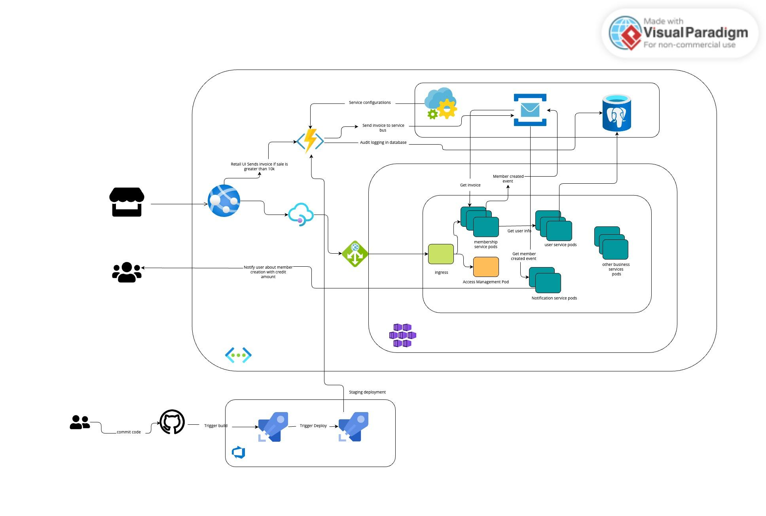

## **Implementation**

* UI App is developed on angular framework.
* UI will be deployed on app service in Azure.
* membership, users and other business services will be following a microservice architecture and will be deployed in Azure kubernetes service as these services are full time running services.
* API management is done via API management service which is integrated with Azure application gateway.
* For implementing the default deluxe member feature a spring boot based java service has been deployed in azure functions.
* Azure function will perform the logging of the database and will send an invoice request to azure service bus to be further consumed by membership service.
* Azure function will get its configurations from App config service.
* Deployment of azure functions will be done using Azure devops CI CD pipeline.

## **Deployed Solution**

## **Cost Estimation**

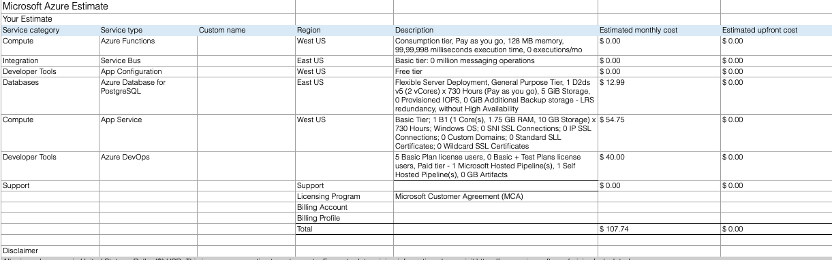

## **Outcome**

* Azure functions can be used for features that are not supposed to be up and running all the time; this also makes you save operational cost as you only pay for what you use.
* Also, service owners should not worry about maintenance aspects of the server as it is being taken care of internally by cloud infra.
* Infra can be scaled automatically based on traffic reaching services deployed.